Packet Tracer – Simulating IoT Devices

1. Topology

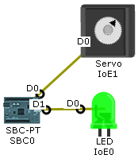

1. Objectives

**Part 1: Build the Circuit**

* **Place the components in the Logical Workspace**
* **Connect the components**

**Part 2: Program the Single Board Computer (SBC)**

* **Run the default program**
* **Modify the default program**

1. Background / Scenario

Packet Tracer has evolved to simulate IoT devices. This tutorial will guide you through the process of placing components in the Logical Workspace, connecting the components, and then programming the single-board computer (SBC) to control them.

1. Required Resources

* PC with Packet Tracer 7.1 or newer installed

1. Build the Circuit
   1. Place components in the logical workspace.
      1. Open **Packet Tracer** 7.1 or newer, and choose the **Components** icon.

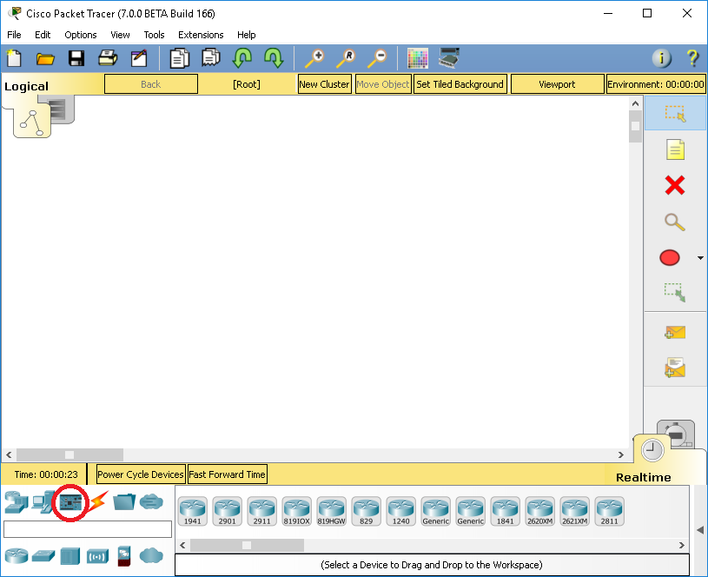

* + 1. Place a **SBC Board** in the **Logical Workspace**.

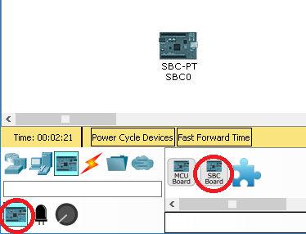

* + 1. Place an **LED** and a **Servo** in the **Logical Workspace.**

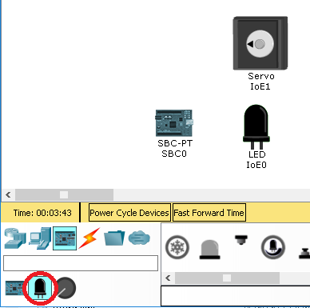

* 1. Connecting the components.
     1. Click the **Connections** icon, select an **IoT Custom Cable**,and connect **SBC0 D0** to **Servo0 D0**.
     2. Select another **IoT Custom Cable** and connect **SBC0 D1** to **LED D0**.

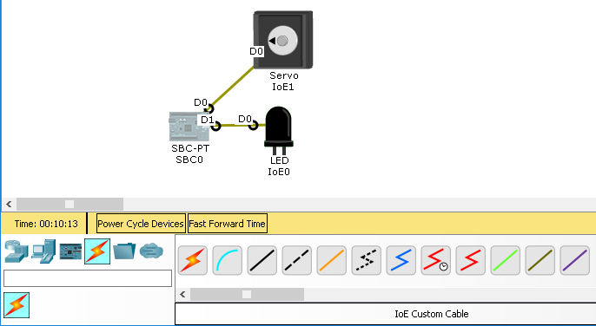

1. Program the Single Board Computer (SBC)

**Note**: Python used in PT is an open source Python to JavaScript interpreter that is not updating to Python 3.0. For this reason there may be slight differences in the syntax between the code observed in PT and that in devices using Python 3.

* 1. Run the default program.
     1. Double-click **SBC0** and select the **Programming** tab.
     2. Double-click **Blink (Python)** in the left pane to open it.
     3. Double-click **main.py** to reveal the default Python code.

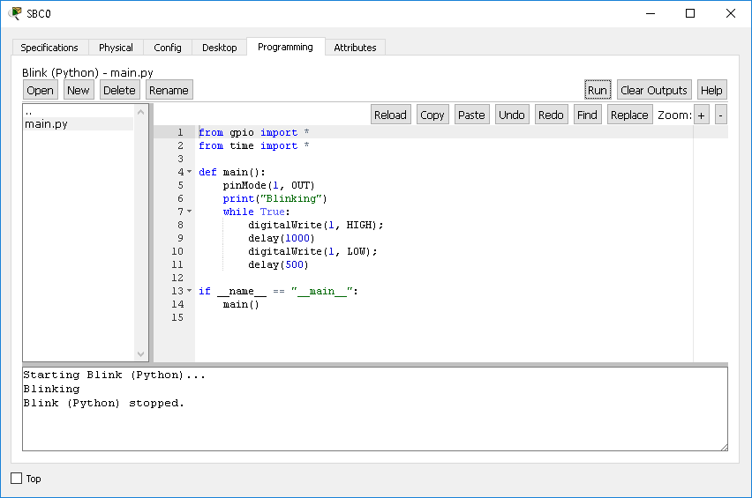

* + 1. Click the **Run** button to run the default code. Return to the Logical Workspace. The LED should be blinking.
    2. Return to the SBC0 Programming tab, and click the **Stop** button to stop the program execution.
  1. Modify the default program.
     1. Copy line 8 of the source code and paste it just below line 8. Do the same with line 11 (formerly line 10) and paste it immediately after the original line of code.
     2. Modify the new lines of code to read:

**customWrite(0, 127);**

and

**customWrite(0, -127);**

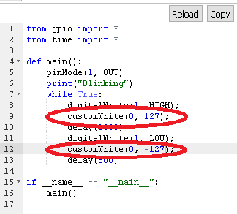

* + 1. Run the modified program. The servo should now move along with the blinking LED.

1. Reflection

What could be changed to make the servo turn in the opposite direction while the LED is blinking?

_______________________________________________________________________________________

_______________________________________________________________________________________